Chapter 14, Solution 14.

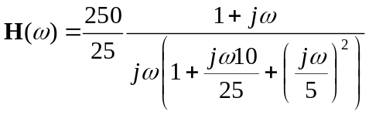

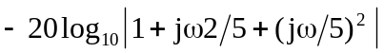

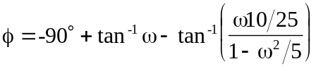

The magnitude and phase plots are shown below.
f
-90°
90°
w
100
1
10
0.1
-180°
H_{dB}
-20
20
w
100
1
10
0.1
-40
40

